Rittal has a new AX three-part wall-mounted enclosure
The all-rounder for industry and IT
Herborn/Hannover, 2024-04-22
Whether to protect control systems in tough manufacturing environments or network applications in offices – or even a combination of both: the new Rittal AX three-part wall-mounted enclosure can handle all requirements. The multi-purpose enclosure connects industry and IT, as required, and also provides myriad benefits for planners, plant manufacturers and operators. They include fast selection, flexible installation and expansion, ease of accessibility, and paperless equipment and system documentation.
The AX three-part wall-mounted enclosure, which consists of a wall section, a middle section and a design door with a large viewing window, can be opened like a fan giving plant manufacturers unimpeded access to the interior of the enclosure. Installations and conversions using the extensive range of Rittal system accessories, or maintenance work can thus be carried out easily, quickly, and conveniently. At the same time, the lockable handle guarantees excellent protection against unauthorised access.

Individual cable entry profiles in the wall section are made using gland plates through the upper or lower side. The sealed gland plates supplied can be replaced with gland plates with brush strips or gland plates with metric knockouts. Inside the wall section, a mounting plate can be used to expand the enclosure with system components. Alternatively, the U-profile perforated mounting strip and VX system punchings provide for the flexible expansion of the wall section along a 25-mm pitch pattern with punched sections and mounting flanges. The middle section of the enclosure provides maximum flexibility for expansion with IT components, including switches, patch cables, and much more. This is due to the 19" mounting level that can be rotated around at 180°, the depth of which can be adjusted using the VX system chassis. Climate control components, such as the Rittal fan-and-filter unit, can also be installed on the sides of the middle section, as required.

Digital wiring plan pocket always to hand
The paperless Rittal ePOCKET system documentation ensures up-to-date access to all key data. As in every Rittal enclosure, this digital wiring plan pocket can be accessed using a QR code. This offers plant manufacturers and operators effortless access to the Eplan Cloud. Inspections and information exchange can thus be carried out quickly and efficiently.

The all-round optimised Rittal AX three-part wall-mounted enclosure replaces its predecessor, the EL model.

 |  | 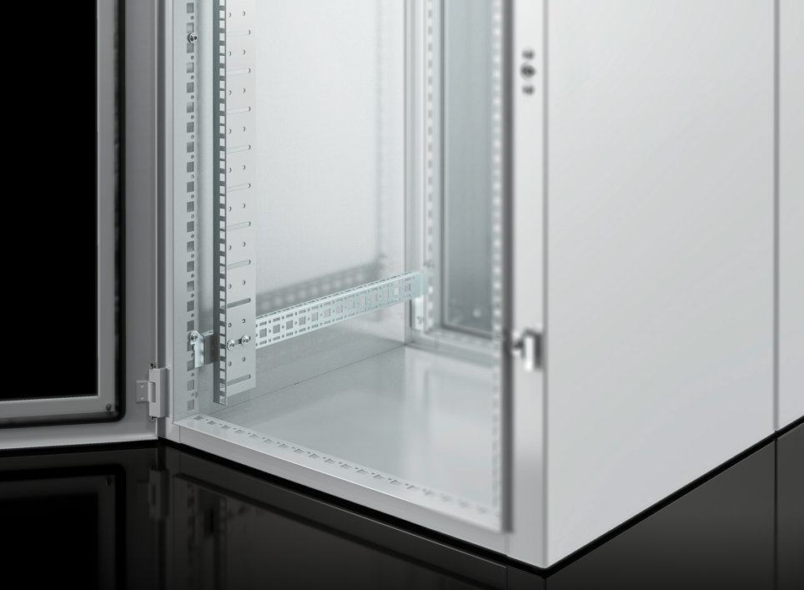
Caption  Image 1 (fri240401100): The three-part enclosure concept – consisting of a wall section, a middle section and a door with a large viewing window – can be opened like a fan. The interior is therefore accessible from all sides. |  | Caption  Image 2 (fri240400700): The 19" mounting angle can be flexibly used in the middle section, depending on the installation depth required.

May be reproduced free of charge. Please name Rittal GmbH & Co. KG as source.

Rittal

Rittal is a leading global supplier of enclosure systems, automation and infrastructure with its industrial, IT, energy and power, cooling and service units. Rittal products and solutions are used in over 90% of global industries – standardised, customised, and always of the very best quality.
Our approach and methodology: Rittal, Rittal Software Systems (Eplan, Cideon and German Edge Cloud) and Rittal Automation Systems (RAS, Ehrt, Alfra) combine their hardware and software expertise to streamline, optimise and digitalise processes across the entire value chain for our customers including their IT infrastructure – from control and switchgear construction, machine building to factory operators or the energy sector.
Our delivery promise: Rittal standard products are delivered in Germany within 24 hours, and within 48 hours throughout Europe.
Customer focus
Improving efficiency and increasing productivity through automation and digitalisation is one of the biggest challenges for our customers. This requires in-depth knowledge and expertise, the combination of hardware and software, and cross-sector networking. We are convinced that creating and connecting data rooms is crucial to the success of industrial transformation. And that is exactly our speciality and field of competence.
Eplan and Rittal are driving the development of the digital automation twin, making data accessible and useable in operations as well. Cideon is improving data consistency in the digital product twin context with its CAD/CAM, PDM/PLM and product configuration expertise. German Edge Cloud’s ONCITE Digital Production System (DPS) makes production process data transparent, enabling it to be optimised – right through to energy management using digital production twins.
Sustainability
Environmental and climate protection, social commitment and ethical corporate management are a given for Rittal. We take our responsibility for a sustainable future seriously. Our approach to resource management and conservation involves continuous improvement of our own production processes and ensuring that our products have the lowest possible Product Carbon Footprint. Our solutions support our customers in achieving their own climate targets.
Family business and global player
Founded in 1961, Rittal is the largest company in the owner-operated Friedhelm Loh Group. The group operates worldwide, with more than 12 production sites and over 95 international subsidiaries. It has more than 12,100 employees and posted revenues of 3 billion euros in fiscal 2023. In 2023, the Friedhelm Loh Group was presented with the “Best Place to Learn” and “Employer of the Future” awards. In 2024, Rittal was awarded the Top 100 Seal as one of Germany’s most innovative medium-sized companies for the third time in a row.
For more information, visit www.rittal.com and www.friedhelm-loh-group.com.

Corporate Communications
Dr. Carola Hilbrand Rittal GmbH & Co. KG
Corporate & Brand Communications Auf dem Stützelberg
Tel.: 02772/505-2527 35745 Herborn
hilbrand.c@rittal.de www.rittal.com


Follow us:

